Distributed P2P NETWORKS.

A network where there is no central server and each node is connected to each other via internet to distribute files or ledger…

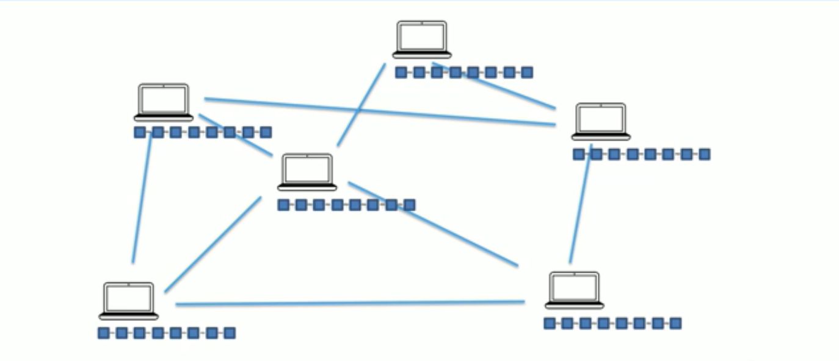

Explaination…………

System 1:

System 2:

System 3:

System 4: